**Dr.Mahalingam College of Engineering and Technology**

Pollachi-642003

Smart Agriculture through Nutrition-Balanced Recommendation and Optimization

**25th August 2018**

**INTRODUCTION**

Agriculture is getting worse in its way now-a-days. But many of young students are taking initiatives to develop agriculture. Since the world is getting digitalized we should also keep on its flow. This was the main reason why this project is going to be developed. The major intuition of this project is to get closer to farmers via digitalized technologies and make their lands more profitable beyond usual yield. The durability is also going to be taken as constraint so that the factor of dry lands will be avoided and during that season rather than usual crops some other crops will be recommended based on the rotation.

It has been planned to develop as an application and will be deployed on all platforms offering compatibility and portability. This will majorly focus neural networks for building relations and data mining for recommendation. This application will be deployed for all agriculturists with adaptable standards.

**Background**

The farmer provides the crop field image as an input to the application. In the pre-processing stage,

Removing noisy Data is done using Multiple Morphological Component Analysis (MMCA) and as a result, filtering the image retaining its necessary portions. SVM prefixed by Spatial Spectral Schrodinger Eigen Maps (SSSE) is used as a classification method wherein partial knowledge propagation is leveraged to improve the classification accuracy.

The classified image along with the Ground truth statistical data containing the weather, crop yield, state & county wise crops are used to predict the yield of a particular crop under a particular weather condition. This predictive model used Ada Boost classifier. Crop recommendation is facilitated then by collaborative filtering. Further scope of the project would extend to predictive analytics on the commodity market of the goods grown in the agricultural fields to predict its waxing and waning.

**Scope and Relevance**

The study focuses on developing a network of clusters containing various attributes as criteria using neural networks concept. The users can definitely use it in an efficient manner as well as it will be their beneficiary factor. Some attributes can be added to the networks only in the form of clusters with the help of admin rights. The Farmers can also mark their presence in the market through this app and can evaluate and compare their product prices with this application and they can sell and earn through this application.

**PROBLEM STATEMENT**

Today the world is developing faster with the large amount of corporate but the basic factor called food which is provided by agriculture was not considered. To improve agriculture the various factors will be made into consideration and the results from them will provide recommendation.

**OBJECTIVES**

The following are the objectives of our proposed idea

* To develop a network of clusters using various attributes. Clusters are called as nodes and the nodes will be hold with various crop attributes and field attributes. Clusters are compared with all other clusters and the matched cluster pattern will be provided as the result.
* To develop a mining algorithm for analyzing crops and soil factors. Result from mining will be used to provide recommendation of crops in future. Crops can thus be cultivated on rotation basis with maximum yield.

**METHODOLOGY**

**Data Flow**

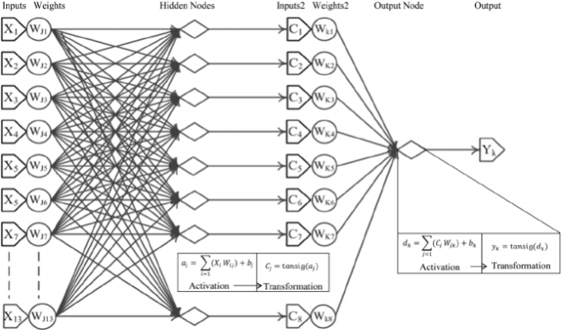

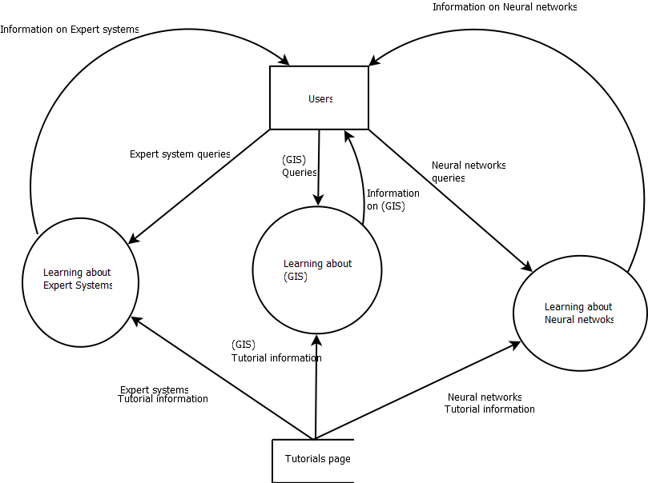

To predict the proper selection of crops various yield prediction algorithm used to help farmers. Traditional yield prediction was performed by considering the farmer's experience on a particular field and crop. The proposed system uses data mining techniques in order to predict the category of the analyzed soil datasets. The category which is predicted will indicate the yielding of crops. The problem of predicting the crop yield is formalized as a classification rule, where Naive Bayes and K-Nearest Neighbor methods are used.

A data mining method like random forests can cope with generating a prediction model when the search space of predictor variables is large. Researcher investigated that the accuracy of random forests to explain annual variation in sugarcane productivity and the suitability of predictor variables generated from crop models coupled with observed climate and seasonal climate prediction indices is limited. Simulated biomass from the APSIM (Agricultural Production Systems simulator) sugar-cane crop model, seasonal climate prediction indices and observed rainfall, maximum and minimum temperature, and radiation were supplied as inputs to a random forest classifier and a random forest regression model to explain annual variation in regional sugarcane yields.

This project proposes a methodology that addresses the problem of unknown future weather by using a

Daily-mean climatic database, based exclusively on available past measurements. It involves building climate matrix ensembles, combining different time ranges of projected mean climate data and real measured weather data originating from the historical database or from real-time measurements performed in the field. Used as an input for the STICS crop model, the datasets thus computed were used to perform statistical within-season biomass and yield prediction.

This work demonstrated that a reliable predictive delay of 3–4 weeks could be obtained. In combination with a local micrometeorological station that monitors climate data in real-time, the approach also enabled us to

(i) Predict potential yield at the local level,

(ii) Detect stress occurrence and

(iii) Quantify yield loss (or gain) drawing on real monitored climatic conditions of the previous few days.

**MODULE DESCRIPTION**

1. **MODULE 1: Interaction Model**

Developing all possible utterances, slot values and intents.

1. **MODULE 2: Dynamic storage and Retrieval from DB**

Database creation with table that will update itself dynamically (add and remove items).

1. **MODULE 3: Building a neural network**

Neural networks is built using various clusters considering all soil and crop factors as attributes.

1. **MODULE 4: Tensor flow convolutional neural network**

The tensor flow will provide the work model for the neural network that is the network will be evaluated based on some criteria and the criteria’s should be satisfied to get the result.

1. **MODULE 5: Create API in python using flask**

APIs are the tools for making information and application functionality accessible over the internet.

1. **MODULE 6: Integrating the Application (cross platform app development)**

Integration is done because we cannot judge a user whether he is using android or windows that is why cross platform facility is also enabled to be provided for all kinds of platforms.

**WORK PLAN**

|  |  |  |  |  |  |  |  |  |  |  |  |  |  |  |  |  |  |  |  |  |  |  |
| --- | --- | --- | --- | --- | --- | --- | --- | --- | --- | --- | --- | --- | --- | --- | --- | --- | --- | --- | --- | --- | --- | --- |
| Activities | WEEKS | | | | | | | | | | | | | | | | | | | | | |
| 1 | 2 | 3 | 4 | 5 | 6 | 7 | 8 | 9 | 10 | 11 | 12 | 13 | 14 | 15 | 16 | 17 | 18 | 19 | 20 | 21 | 22 |
| Study of base paper |  |  |  |  |  |  |  |  |  |  |  |  |  |  |  |  |  |  |  |  |  |  |
| Detailed study of work flow |  |  |  |  |  |  |  |  |  |  |  |  |  |  |  |  |  |  |  |  |  |  |
| working of logic |  |  |  |  |  |  |  |  |  |  |  |  |  |  |  |  |  |  |  |  |  |  |
| setup cloud environment |  |  |  |  |  |  |  |  |  |  |  |  |  |  |  |  |  |  |  |  |  |  |
| *Datasets* collection |  |  |  |  |  |  |  |  |  |  |  |  |  |  |  |  |  |  |  |  |  |  |
| Development of dynamic Database |  |  |  |  |  |  |  |  |  |  |  |  |  |  |  |  |  |  |  |  |  |  |
| algorithm study of work |  |  |  |  |  |  |  |  |  |  |  |  |  |  |  |  |  |  |  |  |  |  |
| algorithm design |  |  |  |  |  |  |  |  |  |  |  |  |  |  |  |  |  |  |  |  |  |  |
| algorithm implementation |  |  |  |  |  |  |  |  |  |  |  |  |  |  |  |  |  |  |  |  |  |  |
| improving algorithm |  |  |  |  |  |  |  |  |  |  |  |  |  |  |  |  |  |  |  |  |  |  |
| testing AI with Test Case |  |  |  |  |  |  |  |  |  |  |  |  |  |  |  |  |  |  |  |  |  |  |
| Processing a Ai algorithm |  |  |  |  |  |  |  |  |  |  |  |  |  |  |  |  |  |  |  |  |  |  |
| testing and Debugging |  |  |  |  |  |  |  |  |  |  |  |  |  |  |  |  |  |  |  |  |  |  |
| deploy on cloud |  |  |  |  |  |  |  |  |  |  |  |  |  |  |  |  |  |  |  |  |  |  |

**BUDGET**

|  |  |  |
| --- | --- | --- |
| **MATERIALS** | **COST** | **REQUIREMENTS** |
| IBM cloud ,AWS  Webhosting[python]  Dynamic DB | Running time Cost as per billing | Cloud computing architecture refers to the components and subcomponents required for cloud computing. These components typically consist of a front end platform (fat client, thin client, mobile device), back end platforms (servers, storage), a cloud based delivery, and a network (Internet, Intranet, Inter cloud). |